Boy, 12, 'bullied every day for 2 years' reveals horrific injuries after being pinned down and attacked in PE class
Ryan Larcombe came home with an injury in the shape of a hand which was so severe it was raised and looked like a burn
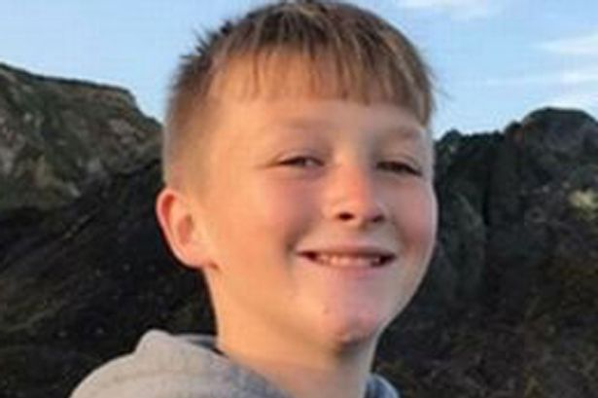Ryan Larcombe, a Year 12 pupil at King Edwards VI Community College in Devon, has revealed the horror injuries he suffered (Image: Devon Live WS)

Get Daily updates directly to your inbox

A 12-year-old schoolboy has revealed the horrific injuries he claims he suffered at the hands of bullies after being tormented every school day for the two years.
Ryan Larcombe shared a shocking photograph of a back injury inflicted on him in the hope of no other child having to suffer the torment he has.
Yesterday, the Year 8 pupil at King Edwards VI Community College in Devon, came home with an injury in the shape of a hand which was so severe it was raised and looked like a burn.
He said it was caused after he was pinned down and repeatedly slapped across the back while getting changed for PE.
The attack stopped when a teacher walked in, he said.
It is the latest in what he describes as a traumatic two years at the hands of bullies who have made him feel 'worthless and traumatised' to the extent he often struggles to eat, sleep and dreads going to school.
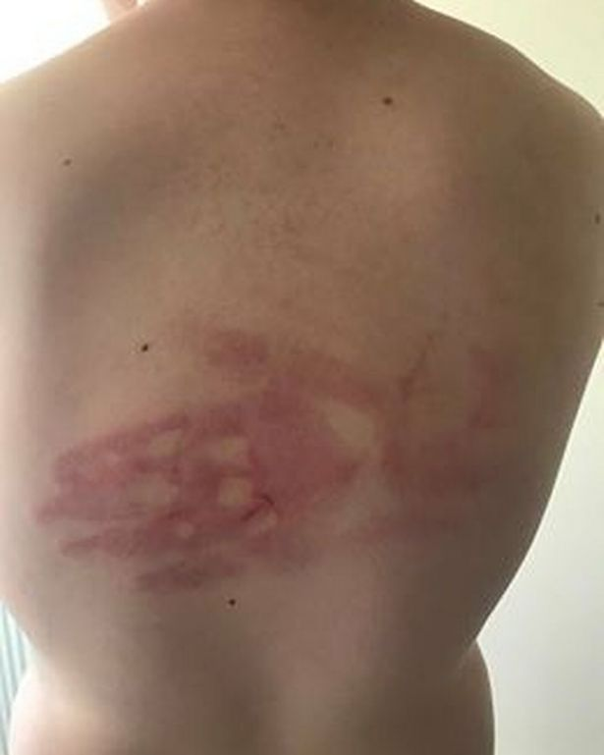
The horrific hand-shaped wound on the schoolboy's back (Image: Devon Live WS)

Ryan, who has been kept off school to recover from his injury, told Devon Live : “I’ve been at that school for two years and not had one day without being bullied.
“I’ve been called fat, not wanted, a waste of space and have been told to go kill myself.
“I know I’m not perfect but I don’t deserve to feel and be treated like this.
"And to top it all off, yesterday I was hurt really badly while in the changing room and everyone just laughed at me.
“I don’t want anybody else to go through the pain I go through. Now I’m scared to school. No child should feel this way.”
His distraught mum Gemma Rowley has described the assault as the ‘last straw’, claiming the school has failed to address to problem which has prompted her to share her son’s injury on Facebook .
The post has already been shared by more than 11,000 people.
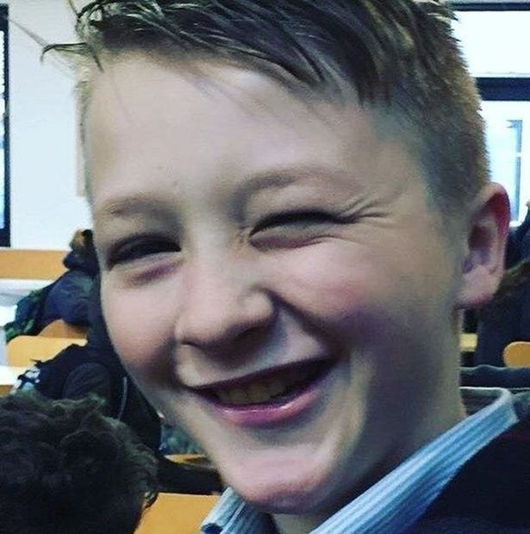
He said he's been left feeling 'worthless and traumatised' (Image: Devon Live WS)
She explained how the school rang her yesterday to inform her about Ryan’s injury so she met him off the bus on his way home, but says she was not prepared for just how bad it was.
Gemma said: “He was pale when he got off the bus and I expected to just see a red mark.
"Instead it was a raised handprint, almost like a burnt and like what you see on cattle. I just can’t understand the force of it.
“I can’t imagine the pain he must have been in. The mark is still there and looks more like a bruised handprint. His back is so sore.
“I’m devastated as you send your child to school to learn and also to find out who they are as a person, but all he seems to do at school is lose a little bit more of himself each time he gets picked on.”
Describing the change she has seen in Ryan over the past two years, she said he has now become a sensitive boy who is paranoid about his weight and often loses his temper.
“When Ryan comes home he is so angry and horrible to me because he can’t deal with what’s happening to him at school,” she said.
“He has not been sleeping and stopped eating and started running because they called him fat. I’ve got more fat on my little finger than he has, but he still thinks he’s fat.
“He’s had his uniform repeatedly ripped, has been dragged through the mud, has been beaten up on the bus and has come home with scratches. Now it has gone to the extreme. This is the last straw.”
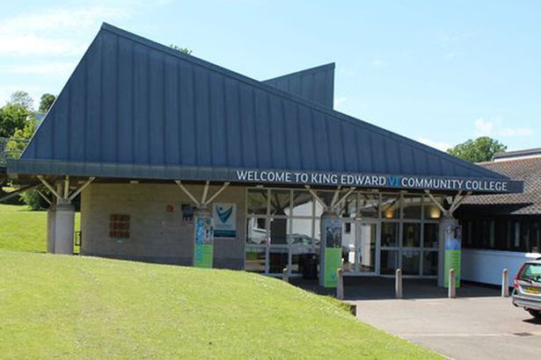
Alan Salt, headteacher at King Edwards VI Community College, said: "We are very upset to hear of any young person suffering from bullying" (Image: Devon Live WS)

Gemma says she has been told the pupils who caused the injury to Ryan have been in isolation at school today which means they have been taught on their own in a classroom away from their peers.
However, she believes they should have been suspended and she has been in touch with the police who have advised her to see first how the matter is dealt with by the school.
She said: “I have spent two years either on the phone or up at the school trying to sort it out but the school never listens.
“I went up there this morning and they were better but I believe that’s because of the Facebook post which I didn’t name or shame the school in.
“I did it just to make them listen to me. Today was the first time I have been able to meet the headteacher.”
Gemma says she has contemplated moving Ryan to a different school but says he has mixed feelings because he has some friends there and it would mean having to travel further away from his home.
She admitted: “It is something I’m considering now because when your child comes home like Ryan has you realise it’s not a safe environment.
“But I don’t want to teach him to run away every time there is a problem. I have been assured by the school they are dealing with the situation.”
Alan Salt, headteacher at King Edwards VI Community College, said: "We are very upset to hear of any young person suffering from bullying.
"Although we do not comment on individual cases, we would reassure our college community that we work with all of our young people, and their families to prevent bullying and to encourage positive, caring relationships between our students.
"We work hard with students and families to address concerns whenever they arise, and to put things right when things go wrong.
"All bullying is unacceptable. We are committed to doing our absolute best for our students, and I would reassure our community and especially our young people that we are determined to prevent bullying wherever possible, and to resolve issues whenever they occur.”

