Name: _______________________________________________
Foundation Unit 2 topic test
Date:
Time: 50 minutes
Total marks available: 46
Total marks achieved: ______

Questions
Q1.
(a) Simplify 5a − 2a
...........................................................
(1)
(b) Simplify 3 × 4y
...........................................................
(1)
(c) Simplify 3e + 4f + 2e − f
...........................................................
(2)
(Total for Question is 4 marks)

Q2.
(a) L = 3a + 2c
a = 5
c = 8
Work out the value of L.
L = ...........................................................
(2)
(b) Kirsty buys some buns.
She buys x packs of currant buns and y boxes of iced buns.
There are 6 currant buns in a pack of currant buns.
There are 8 iced buns in a box of iced buns.
Write down an expression, in terms of x and y, for the total number of buns Kirsty buys.
...........................................................
(2)
(Total for Question is 4 marks)
Q3.
(a) Expand 2m(m + 3)
...........................................................
(1)
(b) Factorise fully 3xy² − 6xy
...........................................................
(2)
(Total for Question is 3 marks)

Q4.
(a) Expand and simplify 5(x + 7) + 3(x – 2)

..............................................................................................................................................
(2)
(b) Factorise completely 3a²b + 6ab²

..............................................................................................................................................
(2)
(Total for Question is 4 marks)

Q5.
(a) Simplify 8x − 3x + 2x
...........................................................
(1)
(b) Simplify 4y × 2y
...........................................................
(1)
(Total for question = 2 marks)

Q6.
(a) Simplify 5f − f + 2f
...........................................................
(1)
(b) Simplify 2 × m × n × 8
...........................................................
(1)
(c) Simplify t² + t²
...........................................................
(1)
(Total for question is 3 marks)

Q7.
(a) Expand 3(x + 4)

..............................................................................................................................................
(1)
(b) Expand x(x² + 2)

..............................................................................................................................................
(2)
(c) Factorise x² − 6x

..............................................................................................................................................
(1)
(Total for Question is 4 marks)

Q8.
* Angela and Michelle both work as waitresses at the same restaurant.
This formula is used to work out the total amount of money each waitress gets.
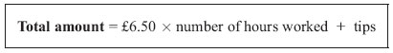
The table shows the number of hours Angela and Michelle each worked last Saturday.
It also shows the tips they got.
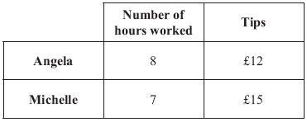
Who got the higher total amount of money last Saturday?
You must show clearly how you got your answer.

(Total for Question is 4 marks)

Q9.
f = 5x + 2y
x = 3 and y = −2
Find the value of f.
...........................................................
(Total for question = 2 marks)

Q10.
(a) Expand and simplify 3(y – 2) + 5(2y + 1)
...........................................................
(2)
(b) Simplify 5u²w⁴ × 7uw³
...........................................................
(2)
(Total for question = 4 marks)

Q11.
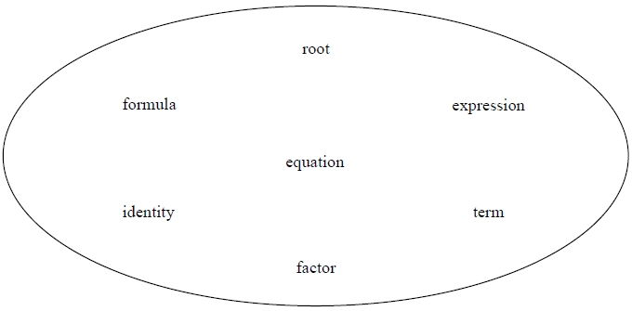
Choose a word from those above that makes this statement correct.
(a) x² is a ............................................... in x² + 4y
(1)
Choose a word from those above that makes this statement correct.
(b) (y + 2) is a ............................................... of 3y + 6
(1)

(Total for question = 2 marks)

Q12.
(a) Factorise y² + 27y
...........................................................
(1)
(b) Simplify (t³)²
...........................................................
(1)
(c) Simplify
...........................................................
(1)
(Total for question = 3 marks)

Q13.
You can use this rule to work out the total cost, in pounds, of hiring a carpet cleaner.
Andy hires a carpet cleaner.
The total cost is £82.20
(a) Work out the number of days Andy hires the carpet cleaner for.
........................................................... days
(2)
Chloe hires a carpet cleaner for y days.
The total cost is £T.
(b) Write down a formula for T in terms of y.
...........................................................
(2)
(Total for question = 4 marks)

Q14.
Dimitar has 20 sweets.
Pip also has 20 sweets.
Dimitar gives Pip x sweets.
Dimitar then eats 5 of his sweets.
Pip then eats half of her sweets.
Write expressions for the number of sweets Dimitar and Pip now have.
Dimitar ........................................................... Pip ...........................................................
(Total for question = 3 marks)

