Name: _______________________________________________
Foundation Unit 1a–b topic test
Date:
Time: 35 minutes
Total marks available: 32
Total marks achieved: ______

Questions
Q1.
(a) Write these numbers in order of size.
Start with the smallest number.
52 102 25 120 55
...........................................................
(1)
(b) Write these numbers in order of size.
Start with the smallest number.
6 −2 0 −5 3
...........................................................
(1)
(c) Write these numbers in order of size.
Start with the smallest number.
0.63 0.633 0.603 0.6 0.06
...........................................................
(1)
(Total for Question is 3 marks)

Q2.
Write 2148 correct to the nearest 100
...........................................................
(Total for question = 1 mark)

Q3.
(a) Write the number seven thousand and twenty five in figures.

..............................................................................................................................................
(1)
(b) Write the number 9450 in words.

..............................................................................................................................................
(1)
(c) Write the number 28.75 to the nearest whole number.

..............................................................................................................................................
(1)
(d) Write the number 7380 to the nearest thousand.

..............................................................................................................................................
(1)
(Total for Question is 4 marks)

Q4.
The table shows the heights of six mountains.
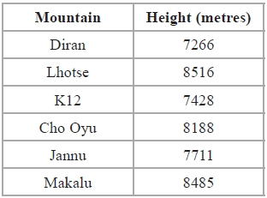
(a) Write down the name of the highest of these mountains.
...........................................................
(1)
(b) Write the number 8188 to the nearest hundred.
...........................................................
(1)
(c) Write the number 7428 in words.
.............................................................................................................................................
(1)
The mountain K3 is eight thousand and fifty one metres high.
(d) Write the number eight thousand and fifty one in figures.
...........................................................
(1)
(Total for Question is 4 marks)

Q5.
The table shows the temperature every four hours one day in December.
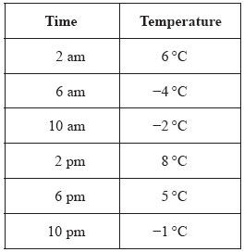

(a) Write down the time with the lowest temperature.

..............................................................................................................................................
(1)
(b) Work out the difference between the temperature at 2 pm and the temperature at 6 pm.

..............................................................................................................................................
(1)
Between 10 pm and midnight the temperature goes down 5°C.
(c) Work out the temperature at midnight.

..............................................................................................................................................
(2)
(Total for Question is 4 marks)

Q6.
Write 4.4354 correct to 2 decimal places.
...........................................................
(Total for question is 1 mark)

Q7.
(a) Write 5643 to the nearest hundred.

..............................................................................................................................................
(1)
(b) Write 197 768 to the nearest thousand.

..............................................................................................................................................
(1)
(Total for Question is 2 marks)

Q8.
28569 people watch a football match.
(a) Write 28569 to the nearest hundred.
...........................................................
(1)
(b) Write down the value of the 2 in the number 28569
...........................................................
(1)
5619 of the 28569 people are female.
(c) Work out the number of males.
...........................................................
(1)
(Total for Question is 3 marks)

Q9.
Work out the number that is halfway between 2.9 and 3.6
...........................................................
(Total for Question is 1 mark)

Q10.
Sally uses her van to deliver boxes to shops.
She can put a maximum weight of 450 kg in the van.
Sally has to deliver 50 boxes to a shop.
Each box has a weight of 30 kg.
Work out the least number of times Sally has to drive to the shop to deliver all 50 boxes.
You must show all your working.
...........................................................
(Total for Question is 3 marks)

Q11.
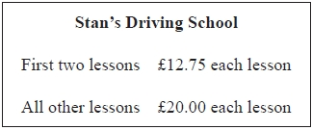
Alex has 5 lessons with Stan's Driving School.
(a) Work out the total cost.
£ ...........................................................
(2)
Leah has some lessons with Stan's Driving School.
The total cost of the lessons is £305.50
(b) Work out how many lessons Leah has.
...........................................................
(3)
(Total for Question is 5 marks)

Q12.
Jayne writes down the following

3.4 × 5.3 = 180.2

Without doing the exact calculation, explain why Jayne's answer cannot be correct.
.............................................................................................................................................
.............................................................................................................................................

(Total for question is 1 mark)

